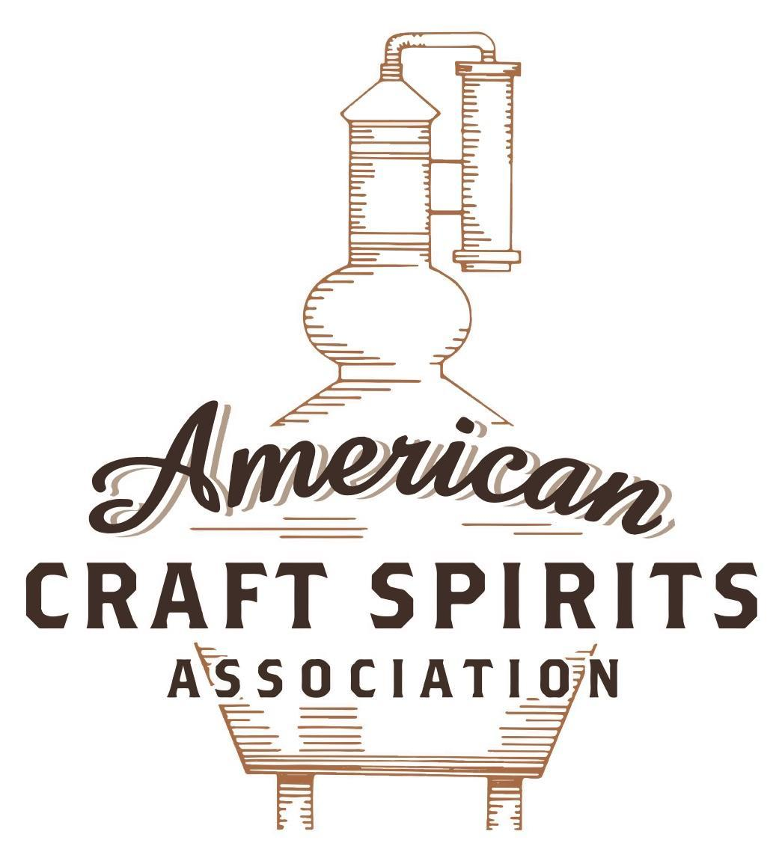
Spirits DtC Shipping Guide

This guide summarizes the direct-to-consumer shipping rules for distilleries in all 50 states and D.C. and also addresses the measures state governments have taken to ease delivery and shipping restrictions during the COVID-19 pandemic.

DtC Quick Guide Comparison

Out-of-State Distilleries  Can Ship Into State? |  |  |  | In-State Distilleries  Can Ship Within State?
State | Yes | No |  | State | Yes | No
AL |  | X |  | AL |  | X
AK | X |  |  | AK | X
AZ | X |  |  | AZ | X
AR |  | X |  | AR |  | X
CA |  | X* |  | CA |  | X*
CO |  | X |  | CO |  | X
CT |  | X* |  | CT |  | X
DE |  | X |  | DE |  | X
DC | X |  |  | DC | X
FL |  | X |  | FL |  | X
GA |  | X |  | GA |  | X
HI |  | X* |  | HI |  | ?*
ID |  | X |  | ID |  | X
IL |  | X* |  | IL |  | X*
IN |  | X |  | IN |  | X
IA |  | X* |  | IA |  | X*
KS |  | X |  | KS |  | X
KY | X |  |  | KY | X
LA |  | X |  | LA |  | X
ME |  | X* |  | ME |  | X*
MD |  | X |  | MD |  | X
MA |  | X |  | MA |  | X
MI |  | X |  | MI |  | X
MN |  | X |  | MN |  | X
MS |  | X |  | MS |  | X
MO |  | X |  | MO |  | X
MT |  | X |  | MT |  | X
NE | X |  |  | NE | X
NV |  | X* |  | NV |  | X
NH | X |  |  | NH |  | X*
NJ |  | X* |  | NJ |  | X*
NM |  | X |  | NM |  | X
NY |  | X* |  | NY |  | X*
NC |  | X |  | NC |  | X
ND | X |  |  | ND | X
OH |  | X |  | OH |  | X
OK |  | X |  | OK |  | X
OR |  | X |  | OR | X
PA |  | X* |  | PA |  | X
RI |  | X* |  | RI |  | X
SC |  | X |  | SC |  | X
SD |  | X |  | SD |  | X
TN |  | X |  | TN |  | X
TX |  | X |  | TX |  | X
UT |  | X |  | UT |  | X
VT |  | X |  | VT |  | X
VA |  | X |  | VA |  | X
WA |  | X* |  | WA | X
WV |  | X* |  | WV |  | X*

WI |  | X |  | WI |  | X
WY |  | X |  | WY |  | X

Notes:
*CA: If passed and signed into law, Senate Bill 620 would allow licensed distilled spirits producers in states other than California and licensed distilled spirits manufacturers or craft distillers in California who obtain distilled spirits direct shipper permits to ship directly to consumers in California
*CT: Consumers with appropriate permit may receive alcohol shipments
*HI: Consumers with appropriate permit may receive alcohol shipments; If passed and signed into law, Senate Bill 65 would allow licensed distilled spirits manufacturers in Hawaii and in states other than Hawaii who obtain direct shipper permits to ship directly to consumers in Hawaii
*IL: If passed and signed into law, Senate Bill 0532 would allow licensed distilled spirits producers in Illinois and in states other than Illinois who obtain distillery shippers’ licenses to ship directly to consumers in Illinois
*IA: If passed and signed into law, House File 639 would allow native distilled spirits manufacturers in Iowa and in states other than Iowa who obtain direct shipper permits to ship directly to consumers in Iowa and to consumers in states other than Iowa
*ME: If passed and signed into law, Legislative Document 1358 would allow distilleries outside of Maine with current manufacturer licenses and distilleries licensed in Maine who obtain spirits direct shipper licenses to ship directly to consumers in Maine
*NJ: (1) If passed and signed into law, Assembly Bill 3167 would allow a craft distillery licensees to ship no more than 9 liters of distilled spirits to a consumer in New Jersey; (2) If passed and signed into law, Senate Bill 3020 would allow craft distillery licensees in New Jersey or in states other than New Jersey to ship no more than 20 liters of distilled spirits to a consumer in New Jersey via common carrier
*NV: Licensed individuals can import one gallon per month of spirits for personal use and the out-of-state supplier must pay excise tax
*NH: If passed and signed into law, Senate Bill 125 would allow licensed liquor manufacturers who obtain direct to consumer shipping permits from the commission to ship directly to consumers in New Hampshire
*NY: Consumer may import up to 90L of liquor per year for personal use without a license; If passed and signed into law, Assembly Bill 3275 would allow licensed liquor manufacturers in states other than New York and licensed distillers and farm distillers in New York to ship no more than thirty-six cases (no more than nine liters per case) of liquor to consumers in New York
*PA: Consumer may place a special liquor order and distiller must ship to a PLCB-operated store
*RI: Distiller can only ship to customer if order was personally placed by customer at distiller's premises
*WA: If passed and signed into law, House Bill 1432 would allow licensed spirits manufacturers in states other than Washington to ship spirits to consumers in Washington
*WV: Distilleries, mini-distilleries, or micro-distilleries licensed in West Virginia or a state other than West Virginia who obtain private direct shipper licenses to ship to a consumer in West Virginia, however the shipments must be made to a retail liquor outlet

COLORADO
Shipment Outbound – Yes, if the outbound state allows it (C.R.S. 44-3-402(1)(d)). Please note that the word “sell” also includes “to deliver for value” (C.R.S. 44-3-103(52)).
Shipment Inbound – No, manufacturers can only sell to the appropriate CO licensees (C.R.S. 44-3-402(1)(c)).
Shipment Intra-state – No, distillery pub licensees may only sell to consumers at their premises for on or off-premises consumption ((C.R.S. 44-3-426(3)).
COVID-19 Measures – Under COVID measures, distilleries with sales rooms can deliver products using employees only and all alcoholic beverages must contain a specific warning label. Third-party delivery services are prohibited (Reg 47-1101; LED Bulletin 20-04; LED Bulletin 20-19). Initially distilleries were not allowed to deliver, but Executive Order D 2020 029, signed on April 6, 2020, expanded delivery rights to distilleries with an approved sales room. Colorado businesses are encouraged to accept the Colorado Digital ID as proof of a person’s age. Delivery and take-out privileges remain in effect and the specific rules depend on status of the locality where the distillery is located (LED Bulletin 20-19). The legislature of Colorado passed H.B. 1027 that was signed into law on June 22, 2021. The legislation authorizes a licensee to sell and deliver an alcoholic beverage to a consumer for consumption off the licensed premises between the hours of 7 a.m. and 12 a.m. A licensee may not sell or deliver more than one liter of spirituous liquors per delivery unless the governor has declared a disaster emergency. A distillery pub license holder is authorized to deliver an alcoholic beverage to a consumer for consumption off the licensed premises through January 1, 2025 and a manufacturer’s license holder who operates a sales room is authorized to deliver an alcoholic beverage to a consumer for consumption off the licensed premises through January 2, 2022.
Link: https://leg.colorado.gov/sites/default/files/documents/2021A/bills/2021a_1027_enr.pdf
Citation (shipment)
Colorado Revised Statutes
C.R.S. 44-3-103. Definitions.
(52) "Sell" or "sale" means any of the following: To exchange, barter, or traffic in; to solicit or receive an order for except through a licensee licensed under this article 3 or article 4 or 5 of this title 44; to keep or expose for sale; to serve with meals; to deliver for value or in any way other than gratuitously; to peddle or to possess with intent to sell; to possess or transport in contravention of this article 3; to traffic in for any consideration promised or obtained, directly or indirectly.
C.R.S. 44-3-402. Manufacturer’s license.
(1) A manufacturer's license shall be issued by the state licensing authority to persons distilling, rectifying, or brewing within this state for the following purposes only:
(a) To produce, manufacture, or rectify malt, vinous, or spirituous liquors;
(b) To sell malt or vinous liquors of their own manufacture within this state. Brewers or winers licensed under this section may solicit business directly from licensed retail persons or consumers by procuring a wholesaler's license as provided in this article 3; except that any malt liquor sold at wholesale by a brewer that has procured a wholesaler's license shall be unloaded and placed in the physical possession of a licensed wholesaler at the wholesaler's licensed premises in this state and inventoried for purposes of tax collection prior to delivery to a retailer or consumer. Wholesalers of malt liquors receiving products to be held as required by this subsection (1)(b) shall be liable for the payment of any tax due on such products under section 44-3-503 (1)(a).
(c) To sell vinous or spirituous liquors of their own manufacture within the state to persons licensed by this article 3 without procuring a wholesaler's license;
(d) To sell malt, vinous, or spirituous liquors in other states, the laws of which permit the sale of alcohol beverages;
(e) To sell for export to foreign countries, if such export for beverage or medicinal purposes is permitted by the laws of the United States; but Colorado distillers, rectifiers, winers, and brewers licensed under this section may sell their products distilled, rectified, or brewed in this state directly to licensed retail licensees by procuring a wholesaler's license.
C.R.S. 44-3-426. Distillery pub license.
(3) During the hours established in section 44-3-901 (6)(b), a licensed distillery pub may, with regard to spirituous liquors fermented and distilled by the distillery pub licensee on the licensed premises:
(a) Furnish its spirituous liquors for consumption on the premises;
(b) Sell its spirituous liquors to independent wholesalers for distribution to licensed retailers;
(c) Sell its spirituous liquors to the public in sealed containers for off-premises consumption, as long as the spirituous liquors are fermented, distilled, and packaged on the licensed premises by the licensee; or
(d) Sell its spirituous liquors at wholesale to licensed retailers in an amount up to two thousand seven hundred liters per spirituous liquor product per calendar year.
Link to statutes: https://leg.colorado.gov/sites/default/files/images/olls/crs2020-title-44.pdf

Citation (COVID-19)

REGULATION 47-1101. DELIVERY AND TAKEOUT SALES AUTHORIZED UNDER EXECUTIVE ORDER(S)
A. Any licensee authorized to engage in sale of alcohol beverages through delivery or takeout pursuant to Executive Order D 2020-011, or any subsequent executive order extending, amending, expanding, or limiting the suspension of statutory license limitations related to sales of alcohol beverages through delivery or takeout, shall comply with the following requirements and limitations, to the extent consistent with any such executive order(s):
1. Orders for delivery or takeout that include alcohol beverages may be accepted by only the licensee or its employees, which may be accepted by telephone, in person, or via internet communication. All orders for delivery shall be documented in a written order prepared by the licensee or its employees.
3. Delivery of orders that include alcohol beverages shall be made only to a person twenty-one (21) years of age or older at the address specified in the order.
4. Delivery must be made by the licensee or the licensee’s employee who is at least twenty-one (21) years of age. Use of third party delivery services is prohibited.
Link: https://www.sos.state.co.us/CCR/Upload/AGORequestEmergency/EmergencyJustificationPathAttach2020-00524.pdf
Colorado Liquor Enforcement Division Notice Guidance Regarding LED Response to COVID-19 BULLETIN 20-03
APRIL 1, 2020
Sealed Containers and Mixed Drinks
While Executive Order D 2020 011 is in effect, certain licensed retailers who are normally limited to selling alcohol beverages for on-premises consumption may sell sealed alcohol beverages to consumers for off-premises consumption via takeout or delivery, as long as food, such as meals and/or sandwiches and/or light snacks, is included with alcohol beverage orders. Both food and alcohol beverages sold for takeout or delivery must be reflected on the same receipt or transaction. Executive Order D 2020 011 applies to the following types of retail licensees:
- Hotel and Restaurant to include Resort Complex and Related Facilities. Hotel licensees may continue to sell food and beverages to hotel guests via room service, mini-bar, and takeout within the premises.
- Brew Pub
- Distillery Pub
- Vintner’s Restaurant
- Fermented Malt Beverage (FMB) On-Premises
- Tavern
- Beer and Wine
- Lodging and Entertainment
- Club licensees can only sell only to club members.

Pursuant to emergency Regulation 47-1001, 1 CCR 203-2, alcohol beverages sold through delivery or takeout must be in a sealed container as defined in Section 44-3-103(51), C.R.S., or in a cup or other container closed securely with a lid taped securely to the cup or other container. Plastic lids are acceptable as long as any holes in the lid are covered with tape, and no straw is inserted through the lid and contents of the cup are not removed once sealed until the beverage is delivered to a person who is at least 21 years of age in their residence. Purchasers and persons delivering alcohol are subject to state and local laws prohibiting drinking or possessing open containers of alcohol beverages in public and in motor vehicles. In addition, all cups or other containers shall be affixed with a label containing a warning statement, with a minimum fourteen (14) font size, stating as follows: “WARNING DO NOT OPEN OR REMOVE SEAL WHILE IN TRANSIT. Purchasers are subject to state and local laws prohibiting drinking or possessing open containers of alcoholic beverages in motor vehicles, including section 42-4-1305, C.R.S.”

All licensees are subject to the following:
• All liquor licensees’ shall follow the emergency Regulation 47-1001, 1 CCR 203-2, Delivery and Takeout Sales Authorized Under Executive Order(s).
• All licensees shall follow the CDPHE Public Health Order’s social distancing requirements.
• Patrons must not be permitted to congregate in groups at liquor licensed establishments during pick-up. Employees and patrons are required to maintain six feet of separation to the greatest extent possible while at a liquor licensed establishment.
• Businesses shall only sell alcohol to individuals who are at least 21 years of age and shall verify age at the time of delivery or when picking up a takeout order.
• All deliveries that include alcohol beverages must be made by an employee of the licensee business. Deliveries of food only may be completed by a third-party service.

Ordering Guidance
All the above-listed license types may receive orders online, in person, telephonically, or through a third-party vendor.
• Licensees may only sell to individuals who are at least 21 years of age (the individual placing the order must provide their name, date of birth, and delivery address). The employee making the delivery must verify the information provided in the order upon delivery;
• Deliveries may only be made to the address provided at the time of the Order. Persons making the deliveries must be at least the age of 21 and an employee of the licensee. Persons delivering must verify the age of the individual receiving the alcohol beverage(s).
• Licensees must also retain all records regarding the ordering and delivery of alcohol beverages pursuant to section 44-3- 701, C.R.S.
• See emergency Regulation 47-1101, 1 CCR 203-2, for additional information and requirements.
Link: https://sbg.colorado.gov/sites/sbg/files/documents/LED%20Bulletin%2020-03%20Guidance%20Regarding%20LED%20Response%20to%20COVID-19.pdf

Emergency Warning Label for Delivery or Take Out
Please see the attached Emergency Warning Label for Delivery or Take Out. The warning label will need to be attached to all Take Out Items of Alcohol Beverages.
Link for warning label: https://multimedia.getresponse.com/getresponse-BNcmV/documents/926f1d3d-7172-4a21-a0b6- 686827c97fbf.pdf
BULLETIN 20-04
DATE: April 8, 2020
The Liquor Enforcement Division (LED) is releasing this bulletin to update the guidance provided to stakeholders in LED Bulletin 20-03, which discussed issues related to the presence of COVID-19 in Colorado, including the impact of Executive Order D 2020 011 - Ordering the Temporary Suspension of Certain Regulatory Statutes Due to the Presence of COVID-19, and the provisions of emergency Regulation 47-1101 – Delivery and Takeout Sales Authorized Under Executive Order(s). Executive Order D 2020 011 temporarily suspended the enforcement of certain statutory limitations to allow retailers normally licensed for on-premises consumption to sell alcohol beverages to consumers for off-premises consumption via takeout or delivery. Executive Order D 2020 011 also temporarily suspended the enforcement of certain statutory limitations to allow manufacturer breweries with an approved sales room to sell malt beverages directly to consumers via delivery. As noted in LED Bulletin 20-03, Executive Order D 2020 011 did not permit manufacturer distilleries and wineries to deliver alcohol beverages to consumers.
On April 6, 2020, Governor Jared Polis signed Executive Order D 2020 029 - Amending and Extending Executive Order D 2020 011. Executive Order D 2020 029 expands the scope of the temporary suspension of statutory limitations to include wineries and distilleries with an approved sales room. While Executive Order D 2020 029 is in effect, these licensees may sell for delivery or take out the types of alcohol beverages they are currently licensed to sell in their licensed premises, including mixed drinks, subject to regulations approved by the State Licensing Authority.

Any licensees—including wineries and distilleries with an approved sales room—that choose to sell alcohol beverages via takeout or delivery pursuant to Executive Orders D 2020 011 and D 2020 029’s temporary suspension of statutory limitations are subject to the requirements in emergency Regulation 47-1101, 1 CCR 203-2. Pursuant to Regulation 47-1101(A), the regulation’s requirements apply to “[a]ny licensee authorized to engage in sale of alcohol beverages through delivery or takeout pursuant to executive order D 2020-011, or any subsequent executive order extending, amending, expanding, or limiting the suspension of statutory license limitations related to sales of alcohol beverages through delivery or takeout.” (emphasis added).

Wineries and distilleries operating an approved sales room MAY continue to sell alcohol beverages to consumers for off-premises consumption via takeout. Under Executive Order 2020 029 and subject to Regulation 47-1101, wineries and distilleries operating an approved sales room MAY also sell alcohol beverages to consumers for off-premises consumption via delivery. Alcohol beverages sold to consumers through takeout or delivery may include mixed drinks. While Executive Order 2020 029 is in effect, distilleries MAY also sell alcohol beverages to consumers through delivery using the licensees’ vehicles or their own employees’ vehicles to make these deliveries. Delivery of alcohol beverages may only be done by an actual employee of the licensee, NOT a third-party service.
Link: https://www.ci.craig.co.us/Document%20Center/Department/City%20Clerk/BULLETIN%2020%204.8.2020.pdf
BULLETIN 20-19
REFERENCE: Guidance on Executive Order D 2020-199
On Sunday, September 20, Governor Jared Polis issued Executive Order D 2020-199, which amends the “last call” provisions depending on where any given locality falls within the three (3) public health “levels” regarding the COVID-19 pandemic.

Under Executive Order D 2020-199, the Colorado Department of Health and Environment (CDPHE) may determine, by issuing a Public Health Order (PHO), when on-premises alcohol beverage sales to end consumers must cease based on what COVID-19 classification status individual counties have achieved.

Localities that have obtained “Protect Our Neighbors” status may continue on-premises sales (as well as takeout and delivery privileges granted to any particular licensee) until 2:00 a.m.

A few points to consider:
• Sales Rooms (wine, spirits, and beer) are included in the order;
• Delivery sales, may continue until 2:00 a.m. for licensees who have such abilities, regardless of level status, or whether or not on-premises sales are allowed during any particular time frame;
• Takeout sales for localities under “Safer at Home” orders must cease by 11:00 p.m., regardless of whether or not on premises sales are allowed during any particular time frame; but such sales may continue until 2:00 a.m. for localities that have obtained “Protect our Neighbors” status.
Link: https://www.colorado.gov/pacific/sites/default/files/Bulletin%2020-19%20FINAL%209.20.20.pdf

The American Craft Spirits Association (ACSA) is working diligently to give our members and industry partners relevant, current updates on statutes and regulations impacting production, sale and distribution of spirits. With the declaration of the novel coronavirus (COVID-19) in early 2020, many states have issued temporary policy changes or longer-term modernization of alcohol beverage laws. State statutes, regulations created by the state alcohol regulatory authority, as well as any other relevant guidance provided by such authorities (such as advisories, opinions, bulletins, etc.) were reviewed in creation of this document. No city or county ordinances were reviewed. Distillers should be aware that even in states where direct shipping is permissible, always remember to avoid shipping to dry counties. Please consult with your state guild or alcohol beverage authority for the most up-to-date information. This content is intended for educational and informational purposes only. ACSA's pro bono law firm of Malkin Law P.A. provided the core content found in this comprehensive overview of the spirits distribution after COVID-19. It was completed in August 2021 and will be updated regularly. If you have updates you would like to provide, please send to legislation@americancraftspirits.org or directly to the law firm at: ryan@malkin.law / malkin.law. Thank you.

